**User:**

For this project, I favoured a bio-inspired design approach, using principles found in nature to optimise energy harvesting.

Based on the above background, I will be designing an energy harvesting device.

The energy harvesting device shall require three key modules:

1. The energy accumulation module functions to derive energy from an external source outside the energy harvesting device.

2. The energy storage module functions to store the accumulated energy inside the energy

harvesting device.

3. The energy utilization module utilizes the harvested energy to power other small devices such as sensors, heating/cooling devices, actuators, and low-power devices.

Please give me as many and reasonable and complete designs as possible.

**GPT:**

Designing an energy harvesting device with a bio-inspired approach is a fascinating project. Here are several design concepts, each focusing on different aspects and sources of energy harvesting:

**Design 1: Solar Leaf Energy Harvester**

* **Energy Accumulation Module**: Mimicking the photosynthesis process in leaves, this module uses flexible solar panels designed like leaves to capture solar energy.
* **Energy Storage Module**: A biomimetic battery system, resembling the structure of plant cells, stores the solar energy efficiently.
* **Energy Utilization Module**: Integrated connectors to distribute energy to small devices, with an emphasis on efficient energy transfer similar to the way plants distribute nutrients.

**Design 2: Wind Foliage Harvester**

* **Energy Accumulation Module**: Leaf-shaped turbines that spin with the wind, capturing kinetic energy.
* **Energy Storage Module**: A central storage unit that mimics the trunk of a tree, with a robust energy storage system.
* **Energy Utilization Module**: Branch-like distribution channels that deliver energy to connected devices.

**Design 3: Biochemical Energy Harvester**

* **Energy Accumulation Module**: Utilizes biochemical reactions, similar to those in plant cells, to generate energy from organic materials or waste.
* **Energy Storage Module**: Compact storage cells that store energy chemically, inspired by natural storage mechanisms like fat cells.
* **Energy Utilization Module**: Bio-compatible connectors for distributing energy to various devices, especially useful in medical or environmentally sensitive areas.

**Design 4: Piezoelectric Raindrop Harvester**

* **Energy Accumulation Module**: A surface that collects raindrops, using the impact to generate energy through piezoelectric materials.
* **Energy Storage Module**: A water droplet inspired storage system, which collects and stores energy in droplet-like cells.
* **Energy Utilization Module**: A network of fine, root-like cables that distribute energy, mimicking the water distribution system in plants.

**Design 5: Thermal Gradient Harvester**

* **Energy Accumulation Module**: Exploits temperature differences, similar to certain thermophilic organisms, to generate energy.
* **Energy Storage Module**: A thermally insulated storage unit that minimizes energy loss, inspired by the insulating properties of certain animal furs or skins.
* **Energy Utilization Module**: Efficient thermal-energy converters to power devices, mimicking the heat utilization in warm-blooded animals.

Each of these designs focuses on a different aspect of nature, harnessing its principles for energy harvesting. The choice of design would depend on the specific environment where the device will be deployed and the type of energy that is most abundant in that setting.

**User:**

Based on the information I provided earlier, are there any other details I should provide regarding the design of the energy harvesting device?

**GPT:**

To further refine the design of your bio-inspired energy harvesting device, there are several additional details that would be beneficial to consider:

1. **Specific Energy Source**: Clarify the primary natural energy source you intend to harness (e.g., solar, wind, thermal, kinetic). This will greatly influence the design of the energy accumulation module.
2. **Environment and Location**: Information about the environment where the device will be deployed is crucial. Factors like climate, weather patterns, availability of light or wind, and the presence of other natural elements can impact the design.
3. **Size and Scalability**: Define the desired size and scalability of the device. Are you aiming for a compact, individual unit, or a larger, scalable system?
4. **Energy Output Requirements**: Specify the amount of energy (in watts or another relevant unit) the device is expected to generate and store. This will affect the design of both the energy accumulation and storage modules.
5. **Target Devices for Powering**: Detail the types of devices or systems the energy utilization module will power (e.g., small sensors, residential appliances). This can influence the design in terms of the power output and distribution method.
6. **Durability and Maintenance Needs**: Consider the expected lifespan and maintenance requirements of the device. This includes materials used, resistance to environmental factors, and ease of repair or replacement of parts.
7. **Budget and Material Constraints**: Outline any budgetary limitations or specific material preferences. This can guide the selection of components and technologies used in the design.
8. **Regulatory and Safety Requirements**: Identify any regulatory standards or safety requirements that the device must comply with, especially if it's intended for use in specific industries or public spaces.
9. **Aesthetic and Ergonomic Considerations**: If the device's appearance or user interaction is important (especially for consumer-facing products), detailing aesthetic and ergonomic preferences can be useful.
10. **Sustainability and Environmental Impact**: Since you're interested in a bio-inspired design, information regarding the desired level of sustainability and environmental friendliness of the device could be crucial.

Providing these details will enable a more tailored and effective design process, ensuring that the final product meets your specific needs and constraints.

**User:**

The energy harvesting device is planned to be deployed in a coastal urban environment in Australia. The design needs to take into account the city where it will be applied to ensure consistent energy output throughout the year. Installation must be straightforward. In terms of maintenance, the unit should be designed to minimise the need for frequent repairs and, where necessary, key components should be easily accessible.

The equipment must comply with Australian Standards for Electrical Equipment. The design should be compact to fit into the limited urban space where the installation is specified. Considering the budget of A$50,000, we should prioritise durable materials, balancing cost and longevity.

Based on previous outputs and above information, please give me as many and reasonable and complete designs as possible.

**GPT:**

Given the specified requirements and the coastal urban environment in Australia, here are several refined design concepts for your energy harvesting device:

**Design 1: Solar-Powered Urban Harvester**

* **Energy Accumulation Module**: Compact, high-efficiency solar panels designed to maximize sunlight capture, even in varying urban shadows.
* **Energy Storage Module**: Robust battery system with advanced energy management to ensure consistent output. Designed for easy access and minimal maintenance.
* **Energy Utilization Module**: Standardized connectors for various urban devices, complying with Australian Electrical Standards.
* **Additional Features**: Corrosion-resistant materials to withstand coastal conditions, and a sleek design to blend into urban landscapes.
* **Budget Consideration**: High-quality solar panels and batteries, balancing initial cost with long-term durability.

**Design 2: Wind and Kinetic Energy Harvester**

* **Energy Accumulation Module**: Small-scale wind turbines combined with kinetic energy harvesters that capture energy from urban movements (e.g., vibrations from traffic).
* **Energy Storage Module**: Integrated, low-maintenance energy storage system, easily accessible for occasional check-ups.
* **Energy Utilization Module**: Efficient power conversion system, designed to power street lights, signage, and small urban infrastructure.
* **Additional Features**: Durable, weather-proof materials suitable for the coastal environment, with a modular design for easy installation.
* **Budget Consideration**: Focus on cost-effective, durable materials and technologies that provide a good balance between efficiency and cost.

**Design 3: Piezoelectric and Thermal Gradient Harvester**

* **Energy Accumulation Module**: Piezoelectric materials in urban pathways to harness energy from pedestrian traffic, combined with a system capturing energy from thermal gradients.
* **Energy Storage Module**: Compact, high-capacity storage units with thermal insulation to protect against coastal temperature variations.
* **Energy Utilization Module**: Configured to supply power to small-scale urban devices, fully compliant with Australian safety standards.
* **Additional Features**: A design that minimizes visual impact and integrates seamlessly into the urban environment.
* **Budget Consideration**: Investment in innovative materials and technologies, ensuring long-term savings in maintenance and energy costs.

**Design 4: Hybrid Solar and Wind Urban Harvester**

* **Energy Accumulation Module**: A combination of small wind turbines and solar panels to ensure a consistent energy supply throughout varying weather conditions.
* **Energy Storage Module**: A hybrid storage system that can efficiently manage energy from both wind and solar sources.
* **Energy Utilization Module**: Multi-purpose connectors adaptable to a range of urban applications, adhering to Australian standards.
* **Additional Features**: Streamlined design for easy installation and maintenance, with materials chosen for longevity in coastal climates.
* **Budget Consideration**: Strategic allocation of budget towards hybrid technology, ensuring optimal performance within the cost constraints.

Each of these designs prioritizes durability, compliance with Australian standards, ease of installation and maintenance, and suitability for the unique conditions of a coastal urban environment in Australia. The budget has been considered to balance the initial investment with long-term performance and sustainability.

**User:**

Based on the design 1,2,3,4 you gave me above, please generate 4 visual concept diagrams.

**GPT:**

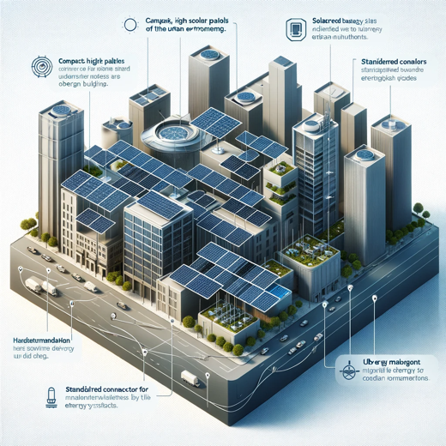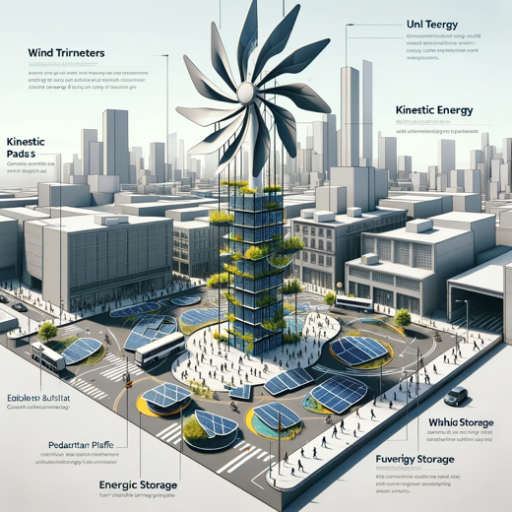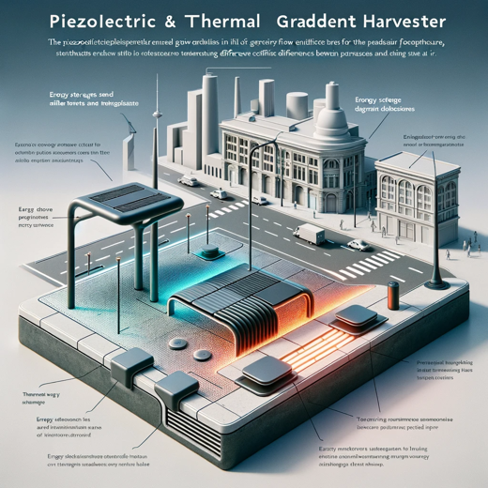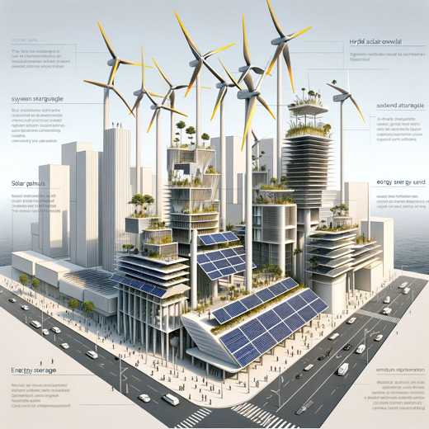

Here are the visual concept diagrams for the four designs:

1. For the Solar-Powered Urban Harvester, the diagram showcases compact, high-efficiency solar panels on urban buildings.
2. The Wind and Kinetic Energy Harvester combines small-scale wind turbines and kinetic pads in an urban setting.
3. The Piezoelectric and Thermal Gradient Harvester integrates piezoelectric elements and thermal gradient systems into the urban landscape.
4. Lastly, the Hybrid Solar and Wind Urban Harvester features a blend of vertical-axis wind turbines and solar panel arrays.

These diagrams represent conceptual visualizations of each proposed design, tailored to the urban coastal environment of Australia.